BIM Use Definitions (BUD) Revisions and Mapping

NBIMS-US™ V4 BIM Use Definitions Workgroup

1 BIM Use Title Revisions 2
2 Common BIM Uses by Phase 3
3 BIM Use Attributes 3

BIM Use Title Revisions
The following table shows revisions to BIM Use titles from previous versions of NBIMS and the BIM PxP Guide.

PSU BIM PxP Guide - 2.1 /  NBIMS V3​ | PSU BIM PxP Guide 3.0​ | NBIMS V4​
Existing Conditions Modeling​ | Capture Existing Conditions​ | Capture Conditions​
Programming​ | Analyze Program Requirement​ | Establish Project Requirements​
Design Authoring​ | Author Design​ | Author Design​
Cost Estimation​ | Author Cost Estimate​ | Generate Estimates​
Phase Planning​ | Author 4D Model​ | Sequence Construction​
Site Utilization Planning​ | Author Construction Site Logistics Model​
Design Reviews​ | Review Design Model(s)​ | Review Design​
Site Analysis​ | Analyze Site Selection Criteria​ | Analyze Design​
Structural Analysis​ | Analyze Structural Performance​
Lighting Analysis​ | Analyze Lighting Performance​
Energy Analysis​ | Analyze Energy Performance​
Mechancial Analysis​ | Analyze Engineering Performance​
Other Engineering Analysis​ | ​
Disaster Planning​ | Analyze Emergency Management​
3D Coordination​ | Coordinate Design Models​ | Coordinate Design and Construction​
​ | ​ | Produce Construction Documentation​
Construction System Design​ | Author Temporary Construction Systems Model​ | Author Temporary Work​
Digital Fabrication​ | Fabricate Products​ | Generate Fabrication Details​
3D Control and Planning​ | Layout Construction Work​ | Layout Construction Work​
Record Modeling​ | Compile Record Model​ | Compile Record Deliverables​
Maintenance Scheduling​ | Monitor Maintenance​ | ​
Building System Analysis​ | Monitor Systems Performance​ | Monitor Performance​
Asset Management​ | Monitor Assets​ | Monitor Assets​
Space Mgmt/Tracking​ | Monitor Space Utilization​ | Monitor Space ​

Common BIM Uses by Phase
The table below shows the typical phase in which the defined BIM Uses are commonly used.
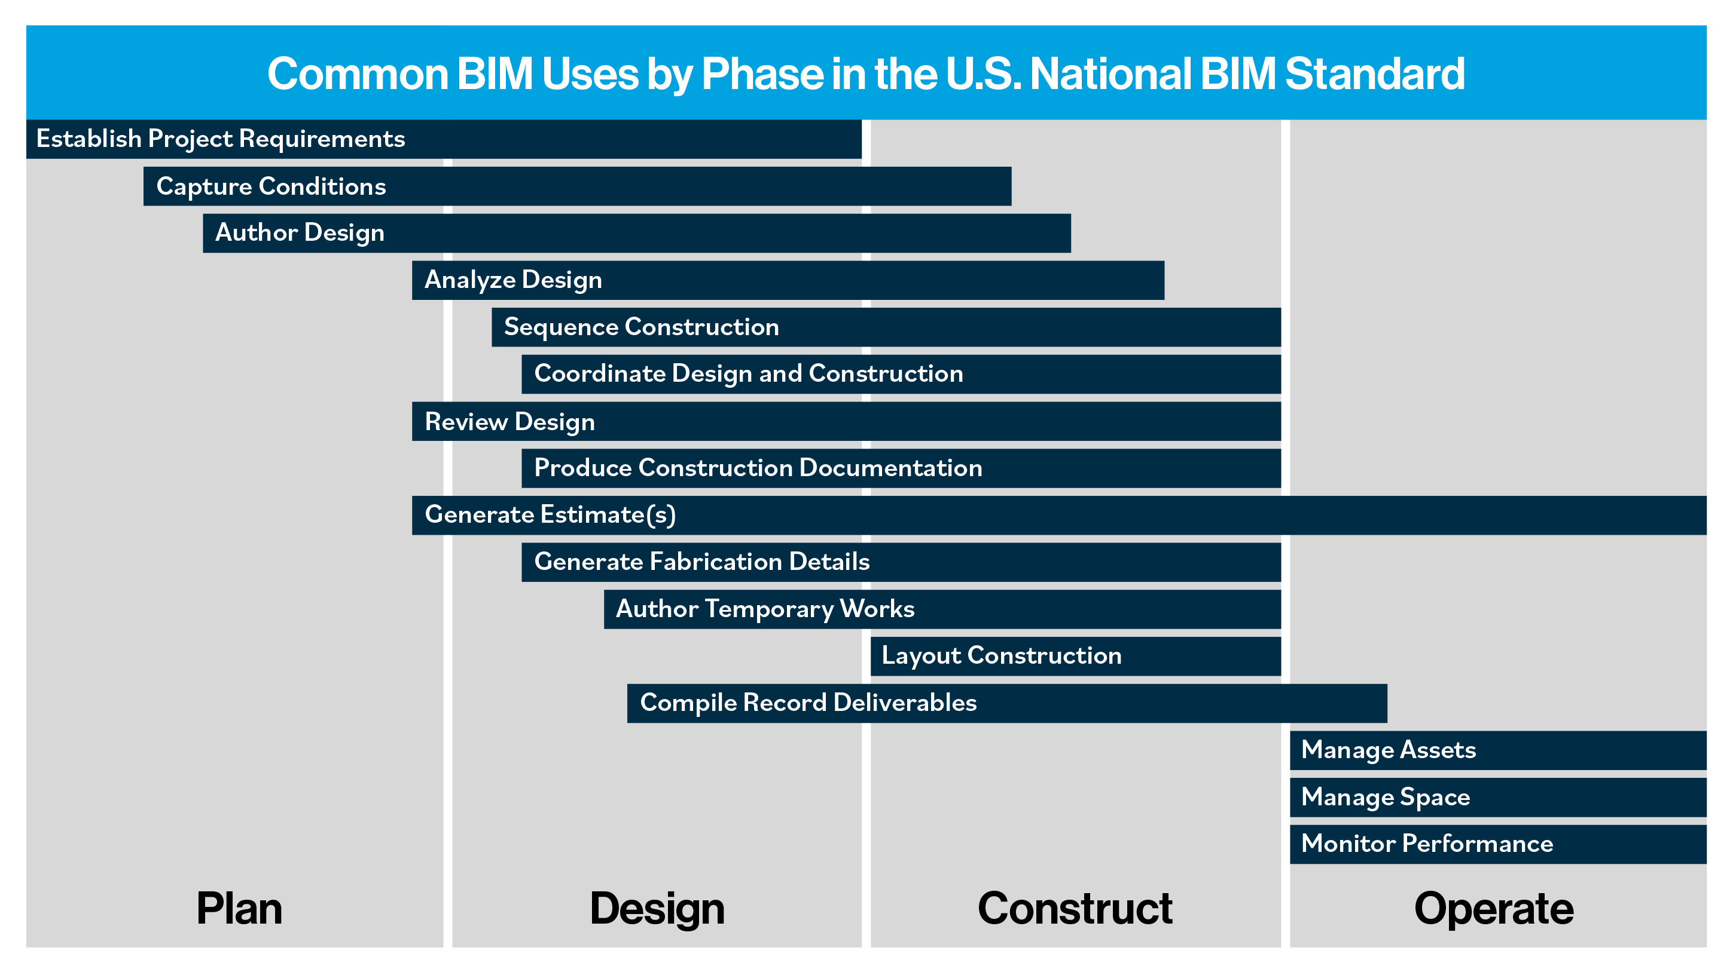

BIM Use Attributes
The following table lists the attributes that should be defined when creating additional BIM Uses.
BIM Use Attributes
Name
Definition
Related Terms
Example BIM Use Cases (Methods and Outcomes)
Potential Benefits
Considerations/Commentary
Inputs
Outputs
Predecessor BIM Use(s)
Successor BIM Uses
Competencies
Methods/Tools
Resources
Version ID
Author

